You Are a Star of God

Click or tap to enter a date.   
**Ages 11-13**

**When**Click or tap here to enter a time.

**Where**Click or tap here to enter a location.

**Program Length:** 2 ½ hours

**Program Description**Discover more about who you truly are as Soul. Have fun seeing your life through spiritual eyes.

**Spiritual Purpose and Benefits**

* Youth explore the divine qualities we have as Soul.
* Youth experience seeing their lives from a spiritual perspective.

**Program Overview**

Pre-Session Volunteer Meeting

Welcome Activity – Decode a Secret Message

HU Song and Group Meeting

Shining Souls – Collaborative Puzzle

Get to Know Soul – Matching Game

Celebrating Soul Tote Bags

(Time Permitting) Paper Stars

Clean Up, Sharing, and Feedback

Pre-Session Volunteer Meeting (45 minutes)

* Introductions and HU Song
* Brief review of volunteer roles
* Safety review
* Program review
* Questions and answers

Welcome Activity– Decode a Secret Message (up to 30 minutes)

Supplies

* Handout: You Are Soul!
* Pens, pencils
* Group Leaders welcome youth as they arrive.
* Group Leaders give youth the handout: You Are Soul!
* Youth can decode the message (quote) from Sri Harold about Soul.
* Youth share the answer they found.
* Group Leaders invite youth to introduce themselves the group.

Welcome, HU Song, and Group Meeting (20 minutes)

Supplies

* A beach ball

🗎 Note to Group Leaders: Please sit with youth during the large group HU and Guidelines/Rules.

* Youth and volunteers come together to stand in a large circle.
* The Room Leader welcomes the youth, explains the activity, and tosses the beach ball to one youth, who will begin the icebreaker activity.
* Each person will take a turn holding the beach ball, sharing their name, where they are from, and a favorite show or game. Then they will toss the beach ball to another person (not someone next to them) and sit down. The next person then takes their turn and so on, until everyone has had a turn to introduce themselves, and everyone is sitting.
* Room Leader introduces the session theme: *Today we are talking about how you are a star of God! We all have physical bodies, and emotions and thoughts (our emotional and mental bodies), but that isn’t who we really are. The real you is Soul, a divine spark of God.*
* Explain what the HU is and how it can help us open our heart’s to God’s love for us and remember that we are stars of God—Soul.
* Lead the group in a HUsong and this spiritual exercise:

*Imagine you are talking with Wah Z about an area of your life that you want help with. He invites you to step into a hot air balloon with him. As you sing* HU*, notice the balloon begin to rise high above the ground. The higher you go, the more you can see.*

*Watch and listen with an open heart as you rise higher and higher. You may see a bright light or hear a spiritual sound from this higher point of view. Feel yourself relax as you surrender your question or challenge to the Mahanta. What does the Master show you?*

* Invite youth to share their experience or a part of their experience with the group, if they wish.

**Guidelines/Rules**

* Room Leader invites youth to participate in creating guidelines for behavior in the youth room.
* Write the guidelines on a flip chart or white board to refer to later as needed.
* *Like following the rules in a game, when everyone plays by the agreed upon rules, the game is a lot more fun!*

Supplies

* Foil-paper puzzle pieces with qualities of Soul glued on them, in envelopes hidden around the room ahead of time
* Poster of a hot air balloon with the Mahanta and a youth in it, 11X17 inches
* Glue sticks

Shining Souls Collaborative Puzzle (30 minutes)

* Youth each find one envelope that is hidden in the room. Each envelope contains a shiny foil-paper puzzle piece with a quality of Soul written on it.
* As needed, Group Leaders guide youth to find the envelopes—which may be taped under chairs/tables, under marker/pen baskets, etc.—by giving clues, such as *You are getting warmer* (when the youth is moving closer)or *you are getting colder* (when the youth is moving further away)*.*
* When youth find an envelope, they open it and glue their puzzle piece in its matching spot on the poster at the front of the room.
* 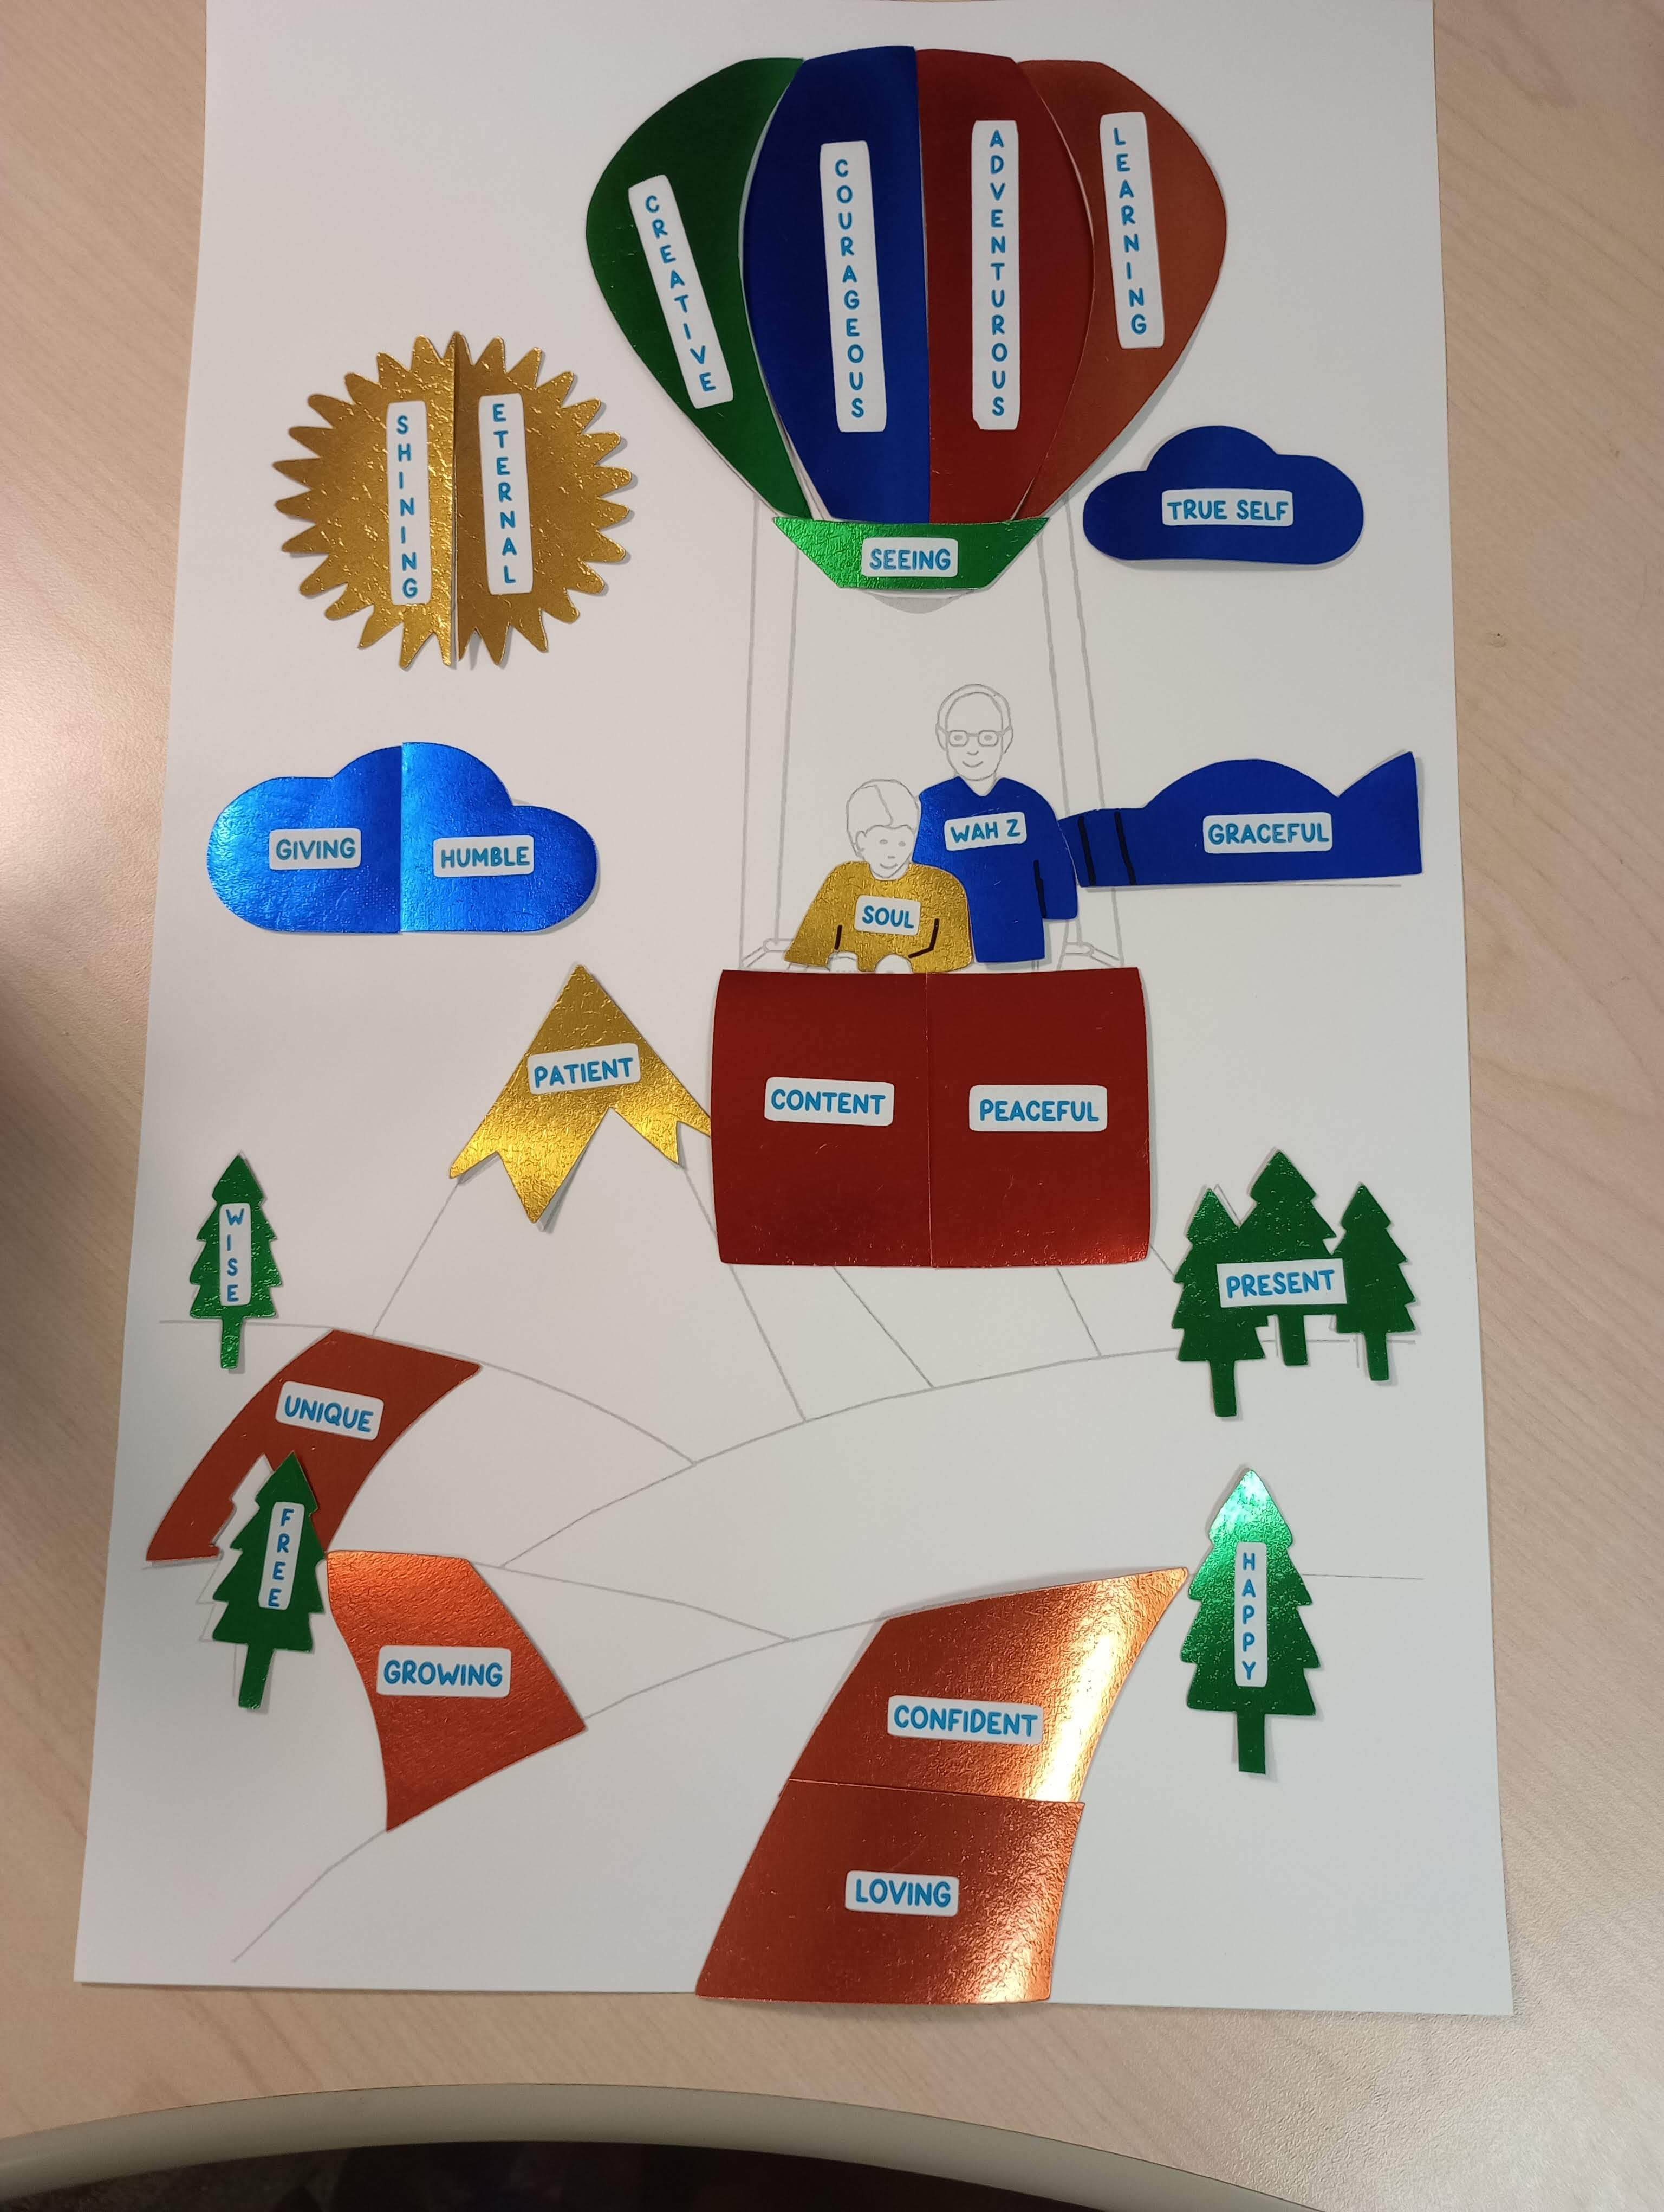The Activity Leader shares how these godlike qualities of Soul allow us to view life from a higher perspective. Ask youth: *What is something in your life that you would like to see from a higher point of view? It could be a spiritual question you have or a challenge you would like help with.*
* The Activity Leader invites youth to write or draw the things they would like to see from the higher perspective of Soul on the poster in the landscape.

🗎 Note: Puzzle pieces are numbered on the back to match with numbered spaces on the poster. Before gluing, check the numbers to be sure pieces are in the correct place.

Get to Know Soul Matching Game (25 minutes)

Supplies

* Two bags or baskets
* Title cards with phrases that describe spiritual principles or qualities related to Soul (cut out)
* Image cards that relate to the title cards (cut out)
* The Activity Leader introduces the game: *We’re going to play a matching game all about Soul, what It’s like, and what It can do. You’ll get to know more about your true self.*
* The Activity Leader asks four Group Leaders to demonstrate how to play the game (see the steps below). The Activity Leader describes what the Group Leaders do, to help youth understand what to do.
* Then, divide everyone into two groups. The first group chooses an image from a bag. The second group choose a title card from the other bag. The titles have blue letters.
* Everyone walks around and shares their cards to find images and titles that can go together. (There are no wrong choices).
* Once they find a match they like, the person with the title card turns their card over and asks the discussion question written with gold letters on the back of their card. Both people share their answers to the question, with each other.
* Youth play the game. It is fine if some youth work in a group of three by matching two images with one title or two titles with one image.
* Youth put their cards back in the correct bags. Then, youth take new cards and repeat the game as time allows.
* When the game is done, Activity Leader has everyone sit together in a large circle again.   
  Ask youth,
  + *What was one of your favorite pictures and titles that you matched together?*
  + *What’s something you learned about Soul that really interested you?*

Break – get a drink of water, use restroom, chat with each other, etc.

Celebrating Soul Tote Bags (40 minutes)

Supplies

* Blank canvas tote bags
* Handouts: Templates for Tote Bags
* Handout: Phrases about Soul
* Carbon transfer paper
* Pencils
* Fabric markers
* Sample decorated tote bag
* The Activity Leader introduces the activity. *The welcome activity today had a hot air balloon to show the higher point of view we have as Soul. What are some other things that remind you that you are Soul and about what Soul can do?*
* *We’re going to make tote bags all about Soul. You can get ideas from quotes from ECK books and use your own ideas about what kinds of words and images remind you of Soul and Soul’s qualities.*
* *Let’s look at the designs you can choose from for your tote bag.*
* The Activity Leader shows youth a sample tote bag with an image and phrase about Soul on it (for example, a silhouette of an eagle and the words “Soul Adventures”).

Youth decorate their tote bags using fabric markers.

* They can draw a picture directly on their bags or use carbon transfer paper and a pencil to trace a template of a symbol that reminds them about Soul and what It can do.
* They can refer to the “Phrases about Soul” handout for inspirational words to write.

Supplies

* Square-shaped paper
* Scissors
* Handout: How to Make a Paper Star

Paper Stars Activity (Optional, after completing their tote bag)

* Youth have finished their tote bag before the program ends can make paper stars, by following the directions in the handout.
* 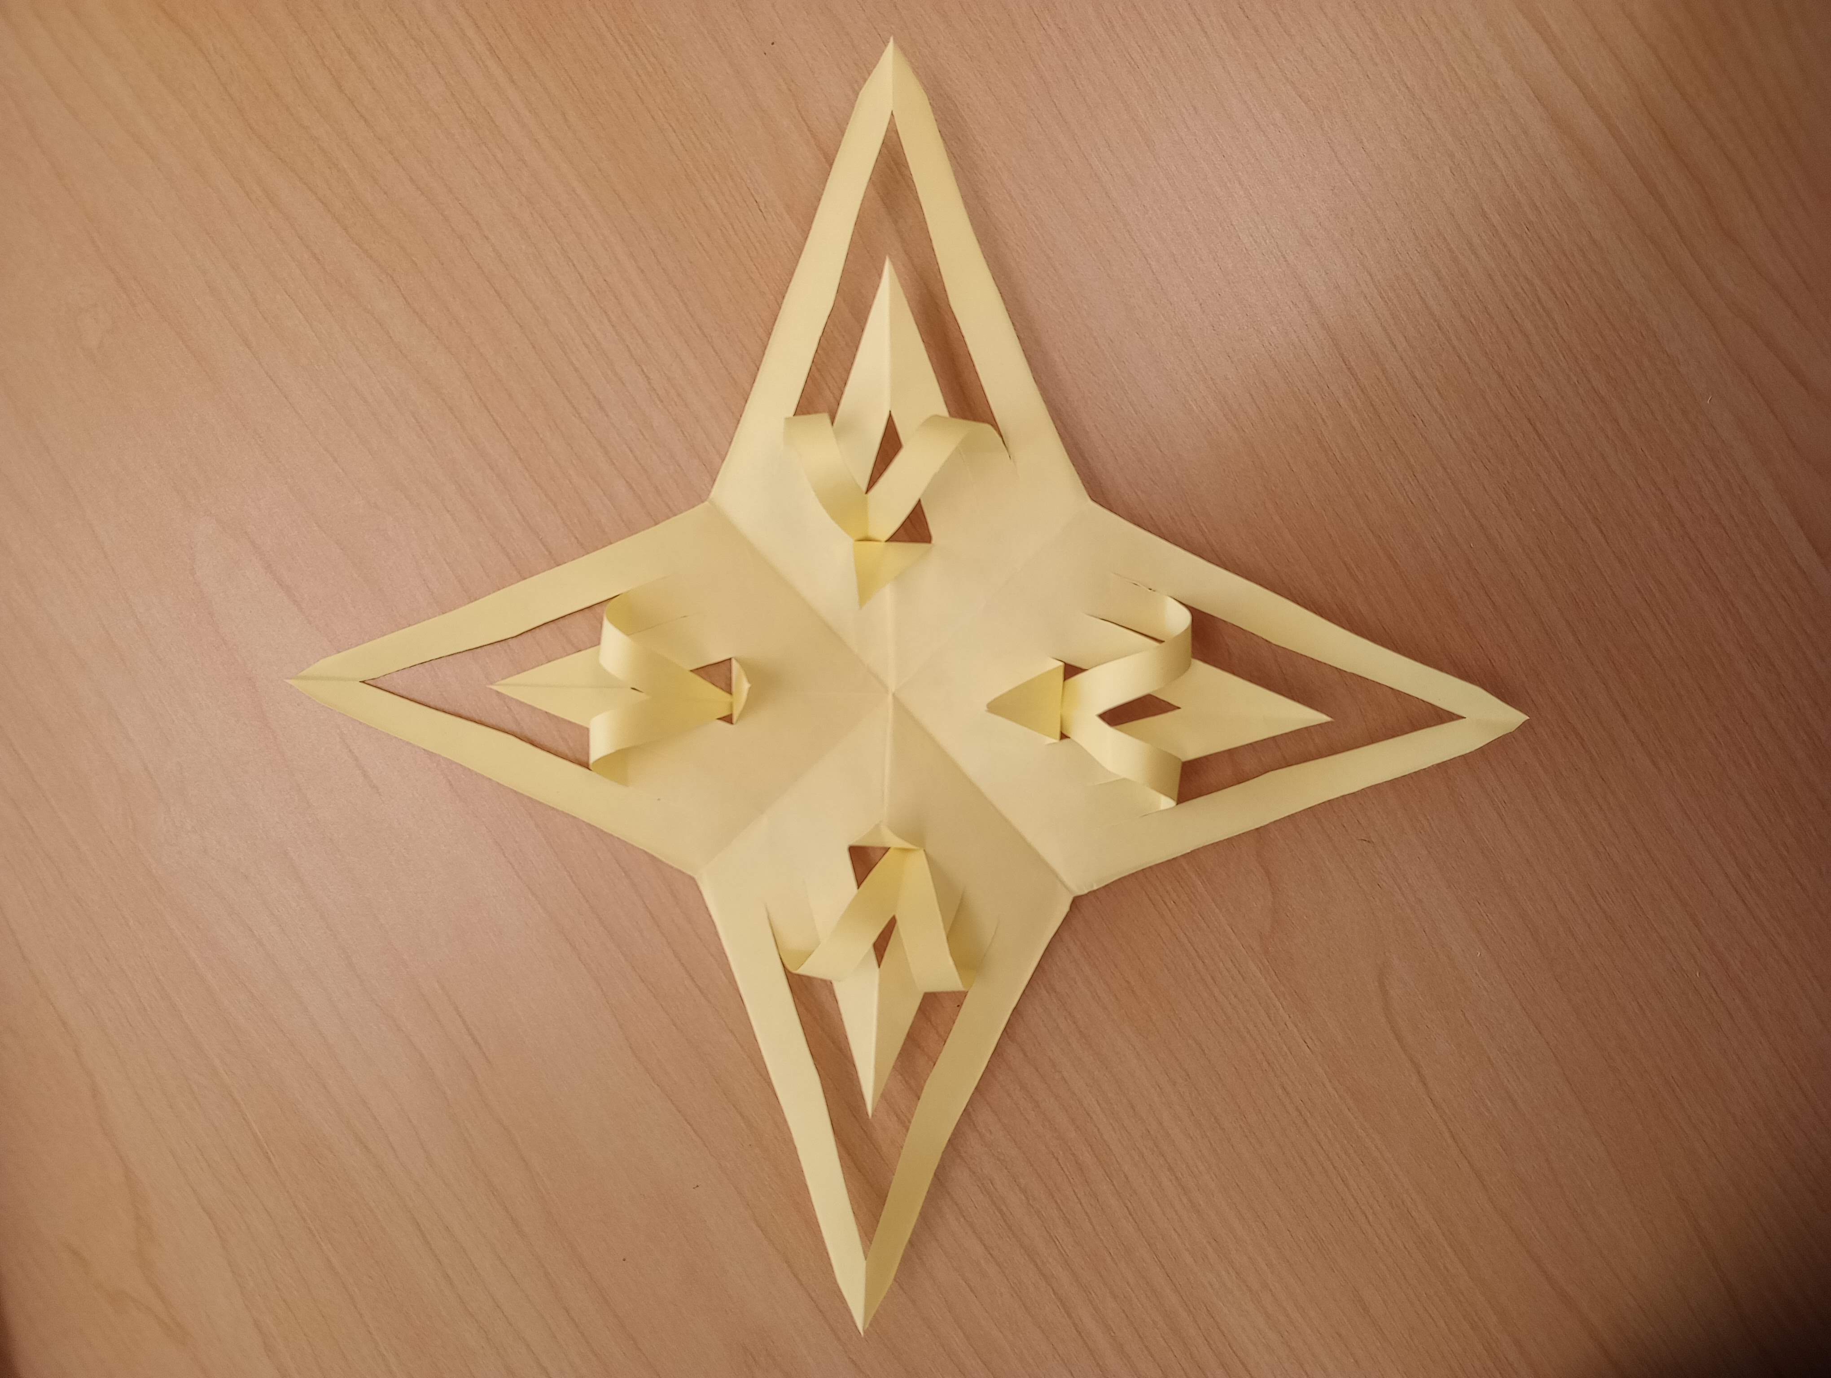Youth can hang up their stars to decorate the room—representing the stars of God that they are!

Clean Up, Sharing, and Feedback(15 minutes)

* Youth help clean up the room.
* Youth sit in a large group.
* Room Leader invites youth to share whatever they’d like to about their experience that afternoon.
* Room Leader asks for feedback on the activities they did that day, and ideas of what else the youth might want to do in future programs.

? Questions to ask can include but aren’t limited to:

1. What did you like doing today?
2. What could make it even better?
3. What kinds of activities would be fun?
4. What spiritual things would you like to learn about?